Lab IV: MapReduce Hands-on Exercises

1. Environment

OS:Win10-64bit

JDK:1.8.0_371

Hadoop version:3.1.3

2. Details of the two tasks

Task 1:

1).map:

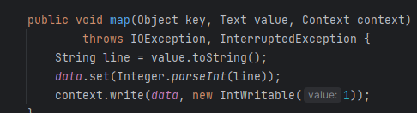

2). reduce:

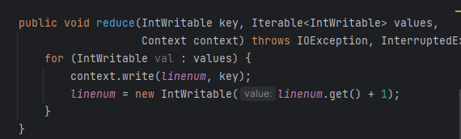

3). main

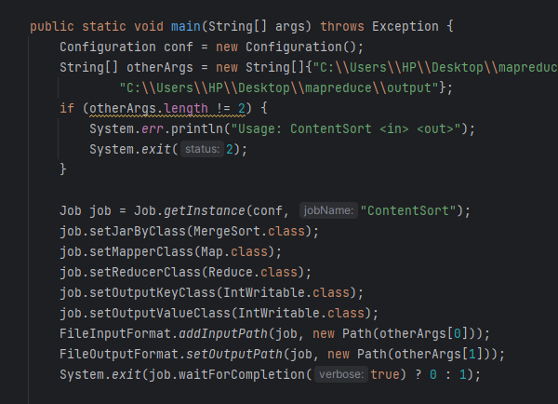

Task 2

1). map:

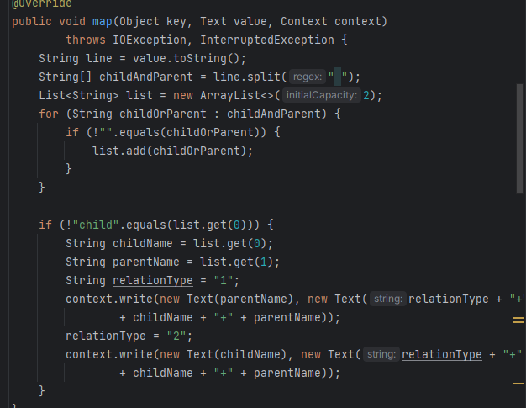

2). reduce

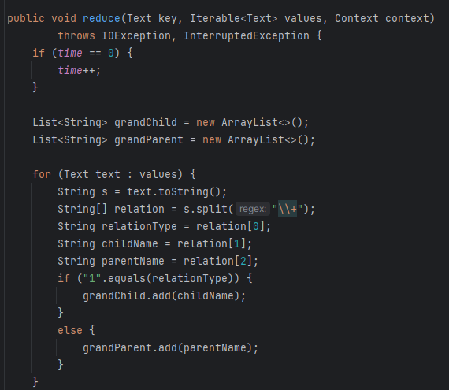

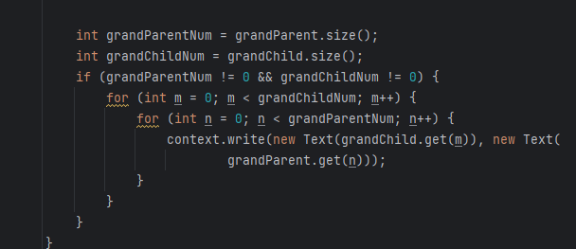

3). main

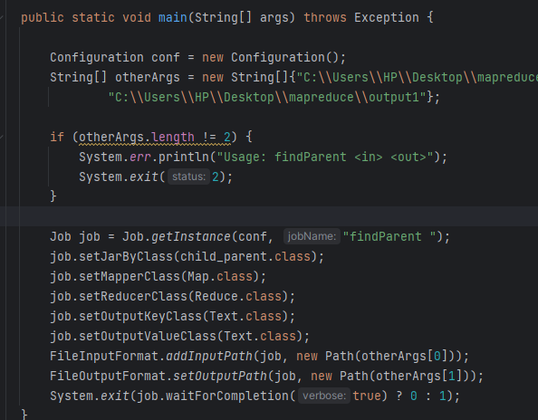

3. Problems

The first time I run the program is on the cluster, but even the code is right, Job failed with state FAILED due to: NA. And I didn’t know why. Then I run the program locally, and mapreduce process successfully run.